# NO:6

**AIM**: program to test relational operators.

**Procedure:**

#!/bin/bash

read -p "Enter first number " a

read -p "Enter second number " b

if (( $a < $b ))

then

echo "a is lesser than b"

fi

if (( $a > $b ))

then

echo "a is greater than b"

fi

if (( $a <= $b ))

then

echo "a is less than or equal to b"

fi

if (( $a >= $b ))

then

echo "a is equal to b"

fi

if (( $a == $b ))

then

echo "a equals b from == operator"

fi

if (( $a != $b ))

then

echo "a not equal to b from != operator"

fi

**output:**

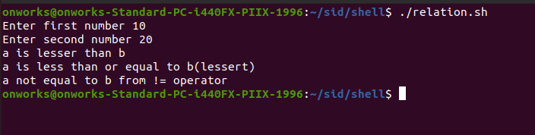

# Result

The program was executed and the result was successfully obtained. Thus CO3 was obtained